Assessment Outline
Assessment Task: Capstone Project Report

Title: Payment Fraud Detection
Introduction
The rapid shift from cash to digital and online payments has significantly increased fraud risk, posing financial, operational, and reputational challenges for financial institutions. Traditional rule-based fraud detection systems are struggling to keep pace with sophisticated and evolving fraud techniques, often resulting in high false-positive rates and missed fraudulent activity. This project explores the use of data-driven, machine learning approaches to detect payment fraud in Ireland, leveraging statistical analysis and predictive modelling to identify high-risk patterns, improve detection accuracy, and support strategic fraud prevention efforts.
Strategic overview
To tackle rising payment fraud, the strategy focuses on data-driven detection using machine learning. High-risk features, Transaction Channels, Geographic Area, Payment Card Types, SCA Classification, Transaction Type, and Confidentiality Flag, are prioritized for monitoring and modelling. Tree-based and ensemble models will capture multivariate fraud patterns, while data preprocessing addresses skewness, imbalance, and low-value features. Continuous model updates and integration with fraud monitoring processes will ensure proactive, adaptive prevention, reduce losses and strengthen customer trust.
Project Plan
- Data collection: Source the Irish payments fraud statistical dataset from data.gov.ie
- Data Cleaning and preprocessing: handle any missing values, normalise features, create derived features by using Python (programming language)
- Exploratory Data Analysis ( EDA): Descriptive analysis, visualisation of fraud and no fraud patterns, examinate class imbalance, examinate correlations, identify potential predictor features, prediction, Chi-squared statistics
- Data Engineering, Encoding, scaling
- Statistical analysis (Bayesian theory, Shapiro-Wilk Test, T-statistic, ANOVA, Levene test etc.)
- Model development: Traditional ML models ( logistic regression, random forest, KNN, Linear regression, etc.. )
- Model Evaluation: Report accuracy of each model, comparisons
- Documentation and presentation: Final report covering all literature review, methodology, result, business insight, limitation, future work and power point presentation

Business understanding
The shift to digital payments has increase fraud risk, creating financial and reputation threats. Traditional rule-based systems are ineffective, requiring data-driven, machine learning approaches for accurate fraud detection.

Data understanding
- Data Structure Overview
The dataset contains 226,678 records and 33 variables, representing aggregated payment statistics for Ireland over six half-yearly reporting periods (mid-2022 to end-2024). Values are reported primarily in Millions of Euros, with some count-based measures, and the dataset occupies approximately 57.1 MB of memory.
The key numerical variable, OBSERVATION, contains substantial missing data (59%) and exhibits an extremely right-skewed distribution. While the mean value is high (179.35), the median is near zero, indicating that most observations are very small, with a few extreme values dominating totals. This confirms strong non-normality, typical of financial transaction data, and suggests the need for log transformation or non-parametric methods in analysis.
The RL_TRNSCTN variable is binary (values 1 and 2), with no missing data and a clear class imbalance (75% value 1). This variable should be treated as categorical, making proportion-based or classification methods more appropriate than parametric tests.
The dataset is highly aggregated, as evidenced by the dominance of broad categories such as “World” for geography, “All” for channels and payment schemes, and “Not applicable / Not allocated” across several dimensions (e.g., fraud type, card function, SCA). Over 60% of records are flagged as confidential, reinforcing the summary-level nature of the data.
Transaction data is mainly classified under card payments, with smaller subsets for contactless, NFC payments, and cash withdrawals. Terminal locations span multiple countries, though global or rest-of-world categories dominate. Fraud-specific fields are largely unspecified, indicating that OBSERVATION values primarily represent total transaction volumes or values, rather than fraud-only metrics.
Overall, the dataset represents macro-level payment system statistics, not individual transaction records. Its structure, skewed distributions, and categorical dominance imply that robust statistical methods, transformations, and categorical analysis techniques are required for meaningful insights.

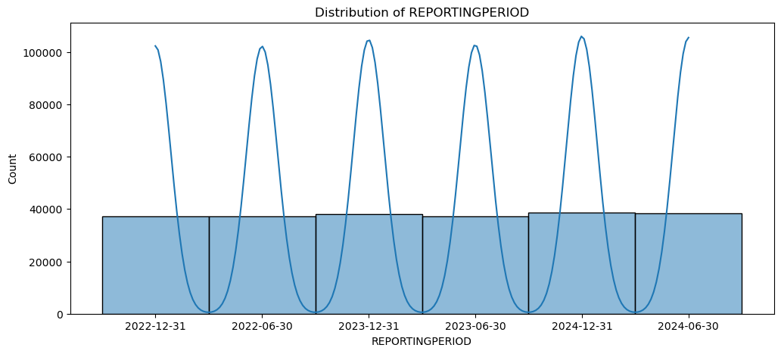
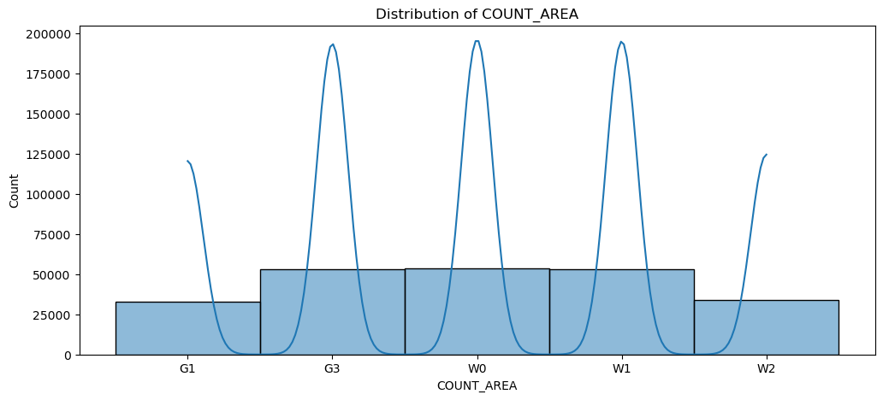
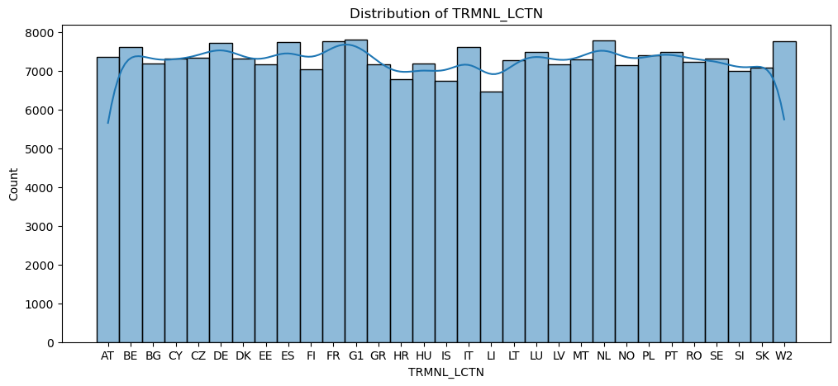
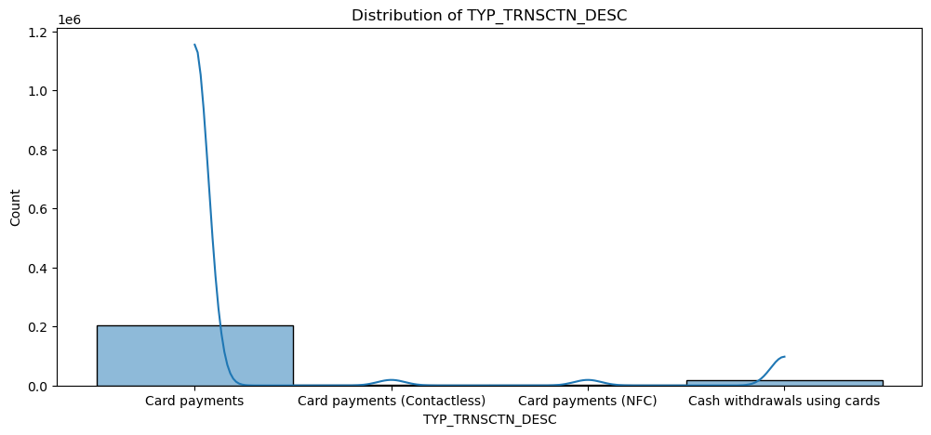
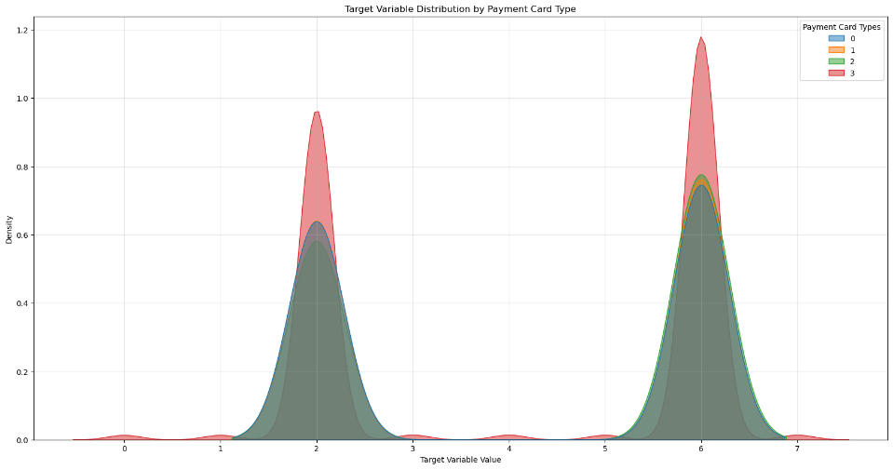
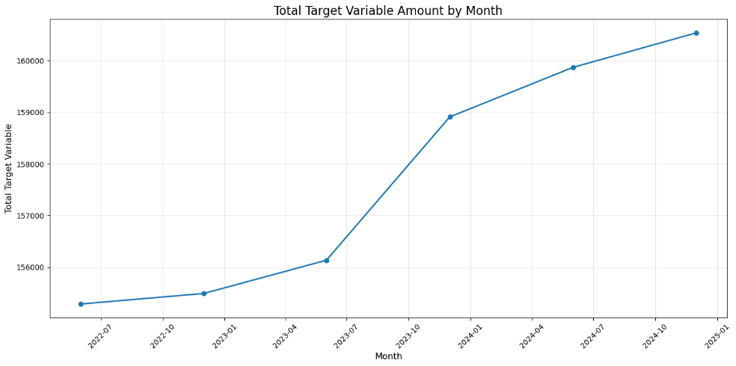

- Outlier removal impact Summary
The original dataset contained 226,678 records, which was reduced to 111,180 records after outlier removal, an elimination of approximately 51% of the data. This indicates an extremely aggressive outlier detection approach, likely based on categorical patterns rather that extreme values in the variables.
The transformed variable “Observation” retained the same range before and after cleaning, confirming that outliers were not defined by numerical extremes, but combinations of categorical attributes. While the mean shifted slightly, the overall scale remained unchanged.
Outlier removal had a major impact on categorical variables. Many transaction types, channels, payment card categories, and descriptors were almost entirely removed, leaving only a single dominant category in multiple dimensions. Notably, three out of four transaction types and most transaction channels were excluded. The Strong Customer Authentication (SCA) variable also changed dramatically, suggesting that most original categories were treated as outliers. The proportion of confidential records was slightly reduced, and the time distribution remained unchanged, indicating that outliers were not time dependent.
Removing over half of the dataset risks eliminating valid and meaningful subpopulations, such as less common transaction types or channels, which are important for fraud analysis. The cleaned dataset represents a narrow, homogeneous subset, dominated by standard or high-volume transactions.
Given the overly restrictive nature and potential loss of important information, outliers will not be removed. The full dataset will be use for analysis and machine learning algorithms.

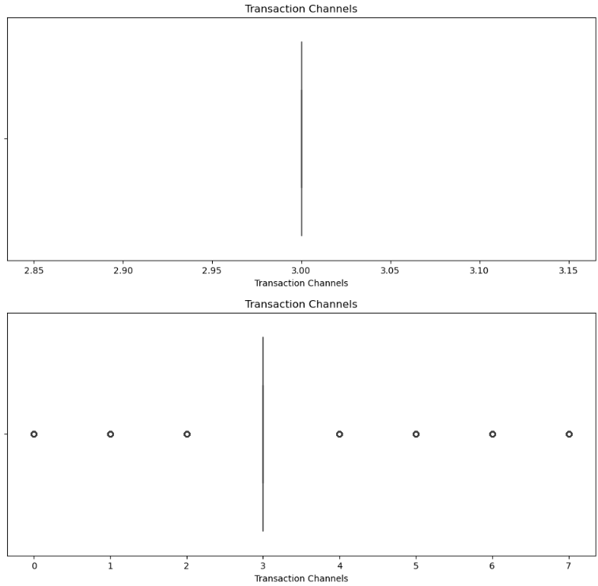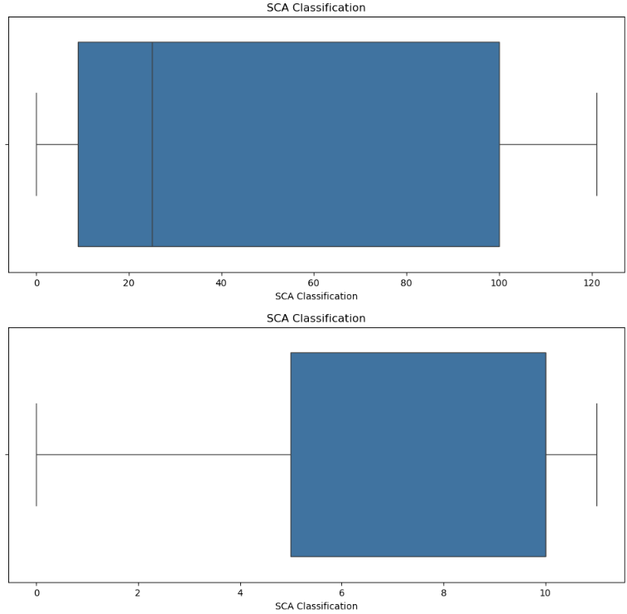

- Statistical analysis
The Bayesian analysis reveals that fraud risk in the dataset is highly structured and concentrated in specific feature combinations rather than being randomly distributed. Payment Card Type 9 emerges as the most critical risk factor, as it is the only card type associated with all fraud categories, including Card Not Received, Counterfeit Card, Lost or Stolen Card, Manipulation of the Payer, and fraudulent issuance of payment orders, while other card types are limited almost exclusively to general Fraud and Not applicable cases. At the geographic level, W2 (Unknown/World 2) shows the highest fraud rate (49.5%) and a uniquely varied fraud distribution, in contrast to most European countries, which display nearly identical counts for minor fraud types, suggesting data balancing or preprocessing effects. Strong Customer Authentication (SCA) Classification 100 mirrors the behaviour of Card Type 9, being both the most prevalent and the only SCA category linked to all fraud types, whereas other SCA classifications are largely restricted to general fraud. Across the dataset, Fraud (Code 2) and Not applicable (Code 6) dominate, accounting for over 90% of all records, with minor fraud types appearing only in deterministic combinations involving Card Type 9, SCA 100, and specific countries. These perfect correlations violate the conditional independence assumption of Bayes’ theorem and indicate that fraud risk is driven by deterministic rules rather than probabilistic variation, likely reflecting data design or aggregation artifacts rather than natural transaction behaviour. Consequently, while the analysis highlights high-risk profiles, particularly Card Type 9 + SCA 100 + W2 or Western European countries, it also underscores significant data quality limitations that constrain the reliability of Bayesian inference for real-world fraud prediction.
The chi-square analysis evaluates the relationship between fraud types and key categorical transaction features and reveals several statistically significant patterns. Strongest associations are observed for Transaction Channels (Cramer’s V = 0.1909), indicating that fraud distributions vary substantially across channels, with certain channels exhibiting markedly higher fraud concentrations. Geographic Area also shows a meaningful, though weaker, relationship (V = 0.0810), suggesting regional differences in fraud exposure. SCA Classification (V = 0.0554) and Payment Card Types (V = 0.0523) demonstrate statistically significant but weak associations, indicating that authentication methods and card characteristics influence fraud patterns to a limited extent. Country exhibits a very weak yet statistically significant relationship (V = 0.0133), implying minimal practical geographic variation at the national level. In contrast, time-based factors (quarter and month) and payment scheme show no statistically significant relationships (p ≥ 0.999), confirming that fraud patterns are stable over time and independent of payment scheme choice. Across all features, Fraud (Type 2) and Not applicable (Type 6) dominate, accounting for approximately 95% of observations, while minor fraud types appear only in specific combinations involving Transaction Channels, Card Types, and SCA Classification. The consistent presence of exactly 36 cases per minor fraud type per country suggests potential data balancing or synthetic structuring rather than naturally occurring variation. Overall, the results indicate that transaction channels, geographic area and SCA classification, and payment card types are most relevant dimensions for fraud risk differentiation, whereas temporal factors and payment schemes offer no predictive values. These findings prove clear guidance for prioritising fraud monitoring efforts and feature selection in fraud detection models, while also highlighting data quality constraints that limit the practical interpretation of the statistical significance.
The histogram and Q–Q plot analysis provides insight into the underlying distributions of the dataset’s variables and highlights several important data characteristics and quality concerns. Several variables exhibit approximately normal distributions, as indicated by reasonably linear Q–Q plots with minor tail deviations. These include Confidentiality Flag, Country Origin, Geographic Area, Country, Transaction Channels, and Transformation Description, suggesting they may be suitable for parametric statistical methods under certain assumptions.
In contrast, a number of variables display uniform distributions, including Payment Scheme, Year, Quarter, Month, and Day. These flat histograms indicate limited variability, with the data covering only specific time windows (e.g., years 2022–2023, months 6–12, and days 29–31). This restricted temporal scope limits the ability to assess seasonality or long-term trends. The Payment Scheme variable shows no variation at all, rendering it analytically uninformative.
Several variables exhibit right-skewed distributions, most notably Payment Card Types and the Target Variable, where fraud codes 2 and 6 dominate. This severe class imbalance suggests that minority fraud types are rare and that imbalance-aware modelling techniques will be necessary. Other variables, such as Transaction Type, Transaction Description, SCA Classification, and Unit Measure, show bimodal or multimodal distributions, indicating the presence of distinct subgroups or mixed data-generating processes. A particularly critical issue is observed in the Transaction variable, which appears to take only two or three discrete values. The stair-step pattern in its Q–Q plot confirms that it is not continuous and has likely been heavily transformed or encoded, significantly reducing its usefulness for statistical analysis or modelling in its current form. Overall, the distributional analysis reveals several data quality concerns, including class imbalance in the target variable, lack of variation in certain features, discretization effects, and limited temporal coverage. These issues necessitate careful preprocessing, such as class balancing techniques, feature transformation, or feature exclusion. From a modelling perspective, tree-based and non-parametric methods are better suited to handle the observed non-normality and skewness. Despite these limitations, several variables stand out as reliable candidates for fraud analysis due to their reasonable distributional properties and previously identified chi-square significance. These include Transaction Channels, Geographic Area, Country, and Payment Card Types. Conversely, Payment Scheme, Transaction, and some temporal variables should be treated with caution or excluded altogether.
In conclusion, while the dataset exhibits notable structural and distributional limitations, it also provides a subset of statistically and analytically robust features. Addressing skewness, class imbalance, and questionable transformations will be essential for building reliable fraud detection models and drawing valid analytical conclusions.

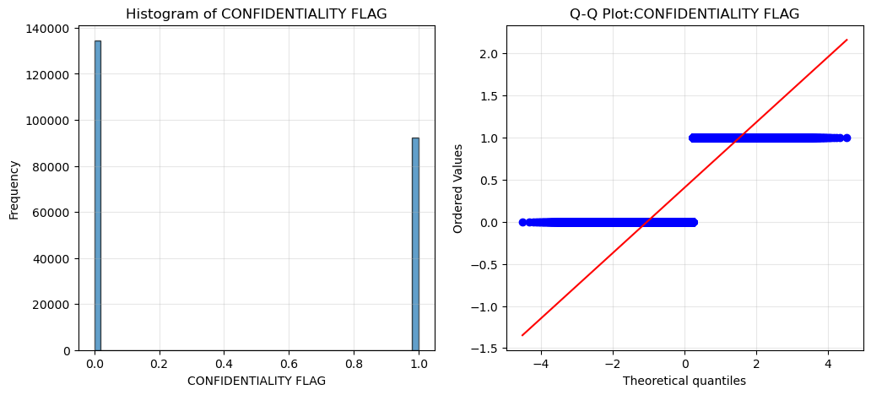
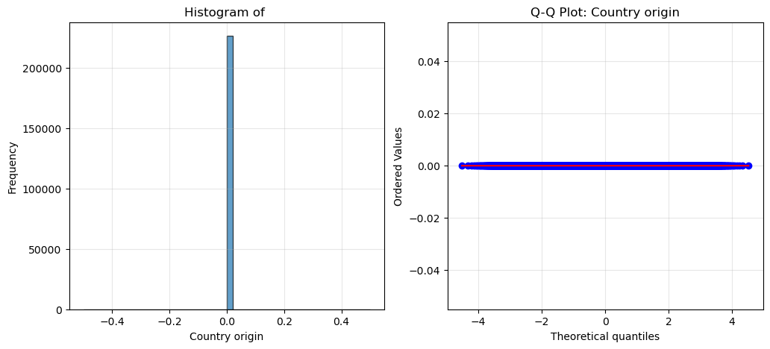
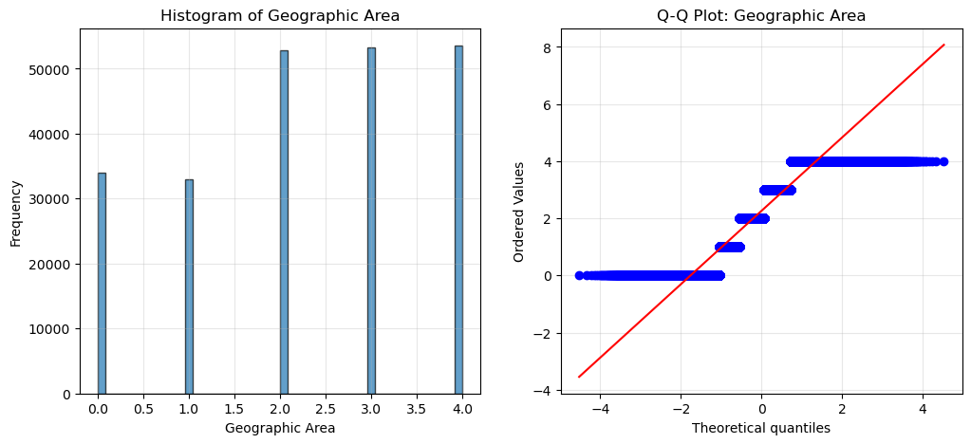
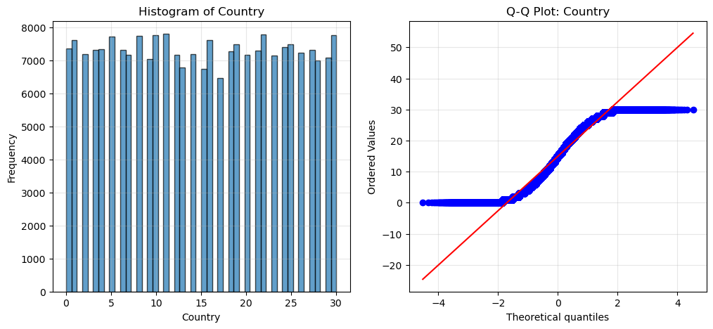
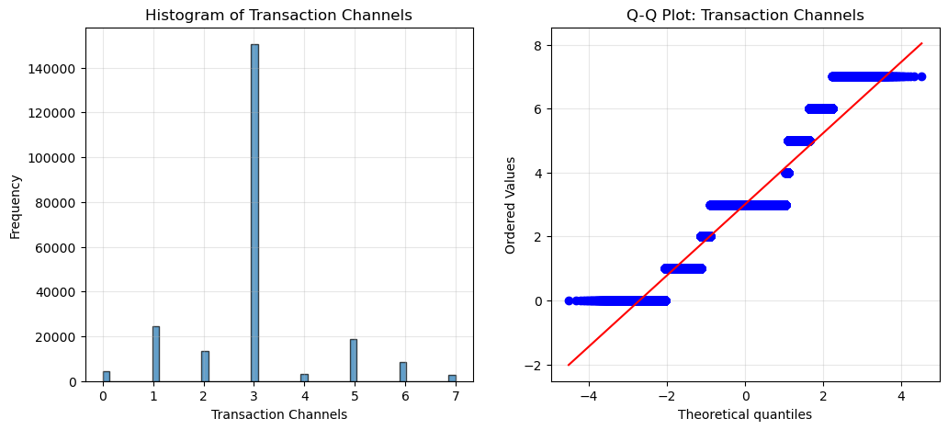
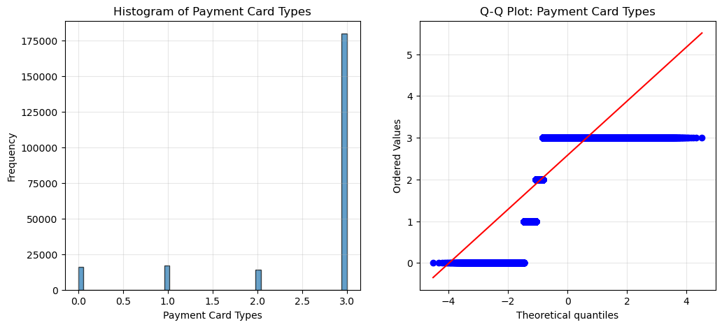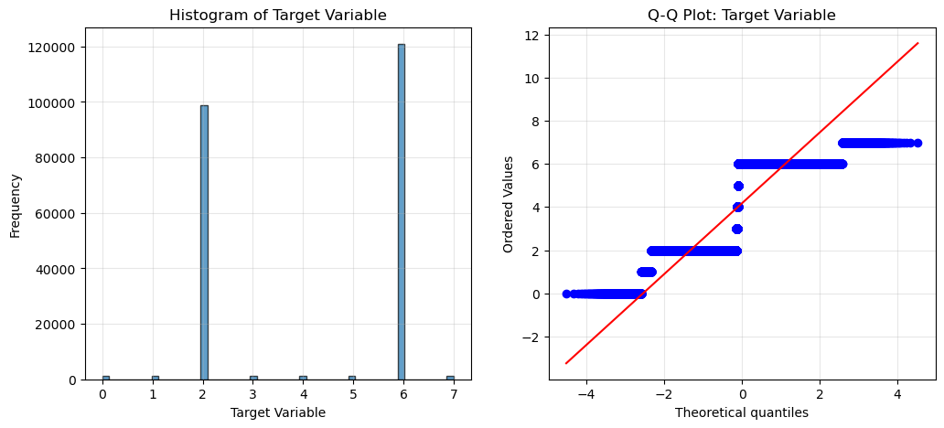

The Shapiro-Wilk test was applied to 18 key variables to assess normality. Four variables—likely UNITS, Country origin, Transaction Descriptions, and Transformation Description—showed perfect normality and are suitable for parametric tests. The majority of variables, however, are non-normal. The Transaction variable is extremely non-normal, confirming histogram observations of severe skew and likely heavy transformation. Transaction Channels, Payment Card Types, SCA Classification, Payment Scheme, and the time variables (year, month, quarter, day) are also non-normal, with some appearing deceptively normal in histograms. Borderline non-normal variables include Geographic Area, Country, Transaction Type, and Unit Measure. These results indicate that non-parametric tests are appropriate for most variables, while tree-based models are well-suited for predictive modelling. Linear models and neural networks may require transformations for stability. Variables such as Transaction Channels, Geographic Area, Payment Card Types, and SCA Classification are high priority due to both statistical significance and predictive potential, whereas Payment Scheme and the Transaction variable may be problematic. Overall, the dataset is predominantly non-normal, which is typical for fraud-related data, and careful method selection and preprocessing are essential.
The one-sample T-test shows that some variables, like Confidentiality Flag and Transaction Type, have non-zero means but appear non-significant, likely due to large sample effects. Significant predictors include Geographic Area, Transaction Channels, Payment Card Types, SCA Classification, Country, and time variables, while the Target Variable mean is 4.17 (codes 2 and 6 dominate).
The Anova results identify three highly significant predictors of fraud. The confidentiality flag is the strongest, with flag 0 transactions showing a 36,8% higher fraud rate than flag 1. Transaction Type is also important: Type 0, 1 and 2 have high fraud rates, while type 3 is significantly saver. Country shows moderate effects, with Croatia, Iceland and Slovenia at the highest risk, and the Netherlands and France at the lowest risk. For fraud prevention, focus on Confidentiality Flag 0, investigate why type 3 is saver, and target high-risk countries. These features should be prioritized in models and business strategies.

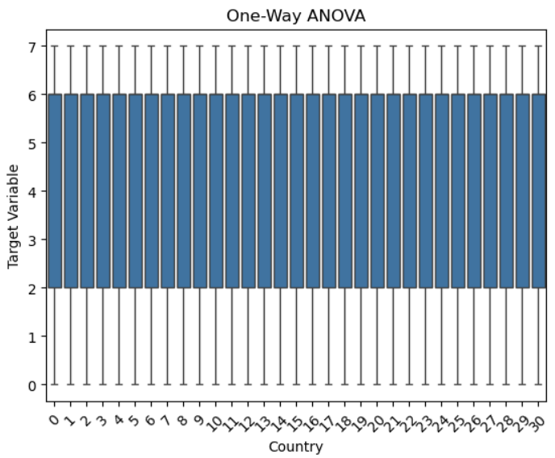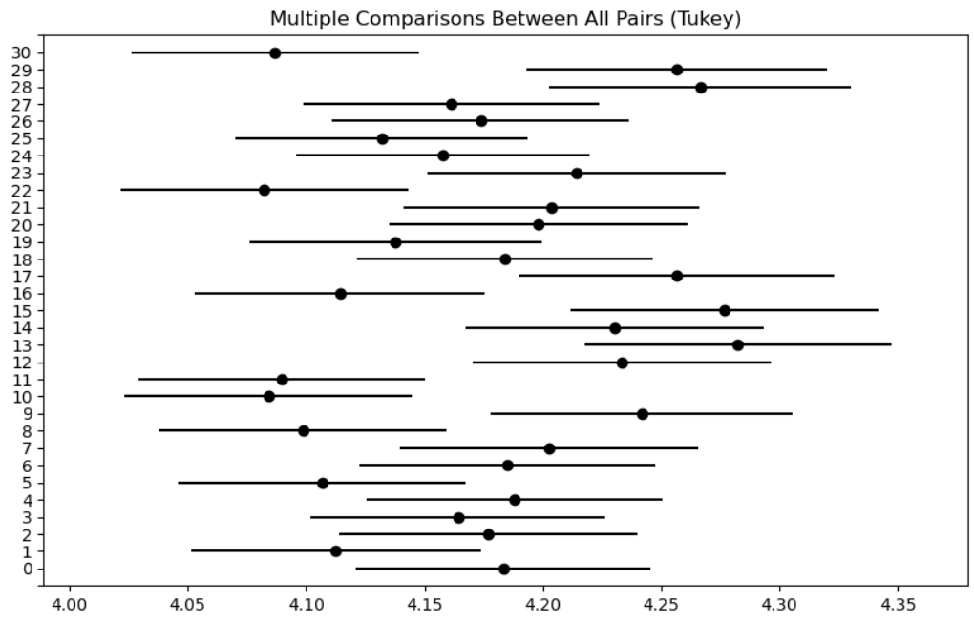

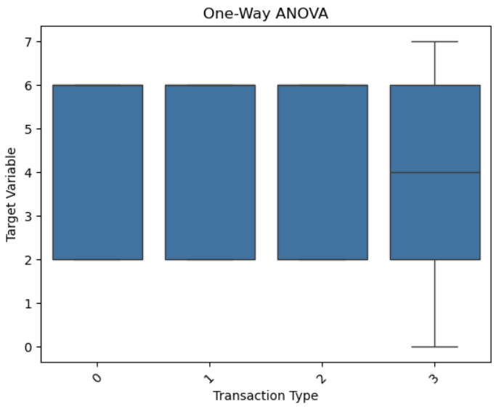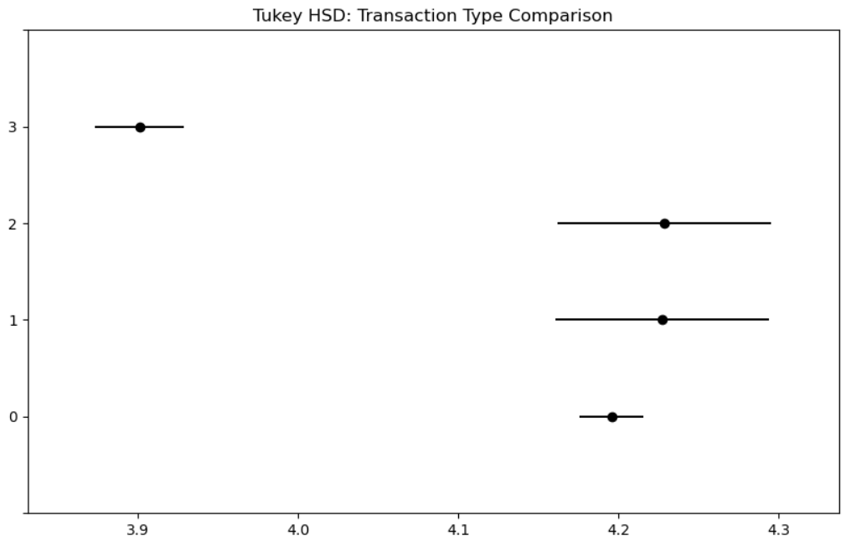
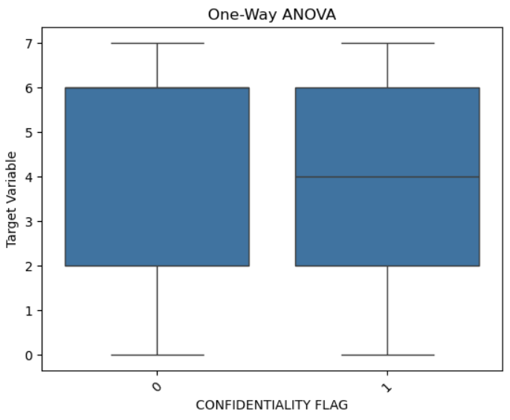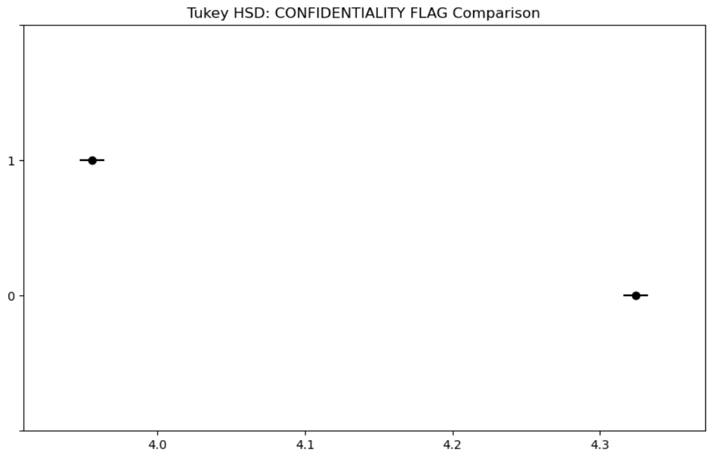

The correlation matrix shows weak direct relationships with the target, though multivariate patterns are evident. Strongest feature correlations include Transaction Type with Transaction Channels (-0.48) and Transaction Decs (-0.50), Transaction Decs with SCA Classification (-0.29), and Payment Card Types with SCA Classification (-0.28). Geographic Area correlates positively with Confidentiality Flag (0.28). Correlations with the target are weak (highest: Confidentiality Flag, -0.09). Constant variables—UNITS, Country origin, Payment scheme, and TRANSFORMATION DESC—can be removed. Temporal features are perfectly collinear, so only one should be used. Fraud-relevant features (Transaction Channels, Geographic Area, Payment Card Types, SCA Classification) show multivariate rather than univariate effects. Transaction Type and Transaction Decs dominate feature-feature correlations, with the Transaction variable showing unusual patterns. Overall, tree-based or ensemble models are recommended, as single-variable correlations are too weak for fraud prediction.

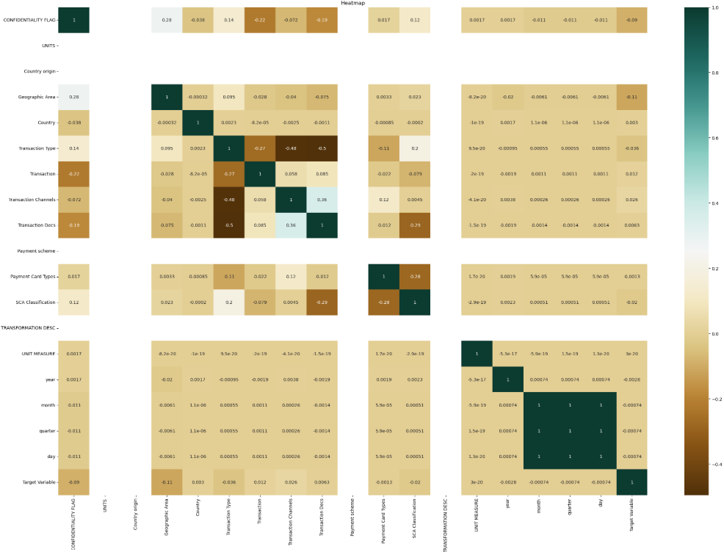

Data preparation
For data preparation, three datasets were combined and 17 repetitive variables were removed. The date variable has been split into Year, Quarter, Month and Day. Fifteen categorical variables were converted to integers using Label Encoding and StandardScaler, avoiding one-hot encoding to prevent excessive columns. Skewness was checked, and three highly skewed variables were transformed.
Findings & Recommendations
Findings:
- Fraud is highly concentrated in specific feature combinations rather than randomly distributed. Key drivers include Transaction Channels, Geographic Area, Payment Card Types, SCA Classification, and certain Transaction Types.
- The target variable is heavily imbalanced, dominated by fraud codes 2 and 6. Minority fraud types are rare and deterministic, limiting some statistical analyses.
- Weak direct correlations with the target indicate multivariate relationships, making tree-based or ensemble models more suitable than single-variable or linear methods.

- Several variables (Payment Scheme, Transaction, some temporal features) have low predictive value and may be excluded from models.
- Data quality concerns include skewed distributions, aggregated data, discretization effects, class imbalance, and limited temporal coverage.

Recommendations:
- Use tree-based or ensemble machine learning models for fraud prediction to capture multivariate patterns.
- Prioritize features with statistical significance and predictive potential: Transaction Channels, Geographic Area, Payment Card Types, SCA Classification, Transaction Type, and Confidentiality Flag.
- Exclude or cautiously handle low-value variables (Payment Scheme, Transaction, certain time features) to improve model stability.
- For strategic fraud monitoring, focus on high-risk profiles (specific card types, SCA classifications, and geographic areas).
- Future improvements should address data quality limitations, expand temporal coverage, and explore advanced predictive methods to enhance fraud detection.

References
- Pandas User Guide, pandas Documentation, 2025
- Data Analysis with Python, GeeksforGeeks, 2025
- Eyre, I., 2025. Using Python for Data Analysis, Real Python
- Bryant, P. (2025) Beyond the Basics: Advanced Feature Scaling Techniques for Real-World Data, Digital Thought Disruption,
- How to Maintain Scalability in Your Python Code, TheLinuxCode
- Scaling to large datasets, pandas Documentation, 2025
- Scaling and normalization of data, StackBay Pandas Tutorials, 2025
- admin, 2025. Chapter 35: Data Transformation: Scaling, Normalization, and Encoding. CircuitLabs
- Principal Component Analysis (PCA), GeeksforGeeks, 2025.
- sklearn.decomposition.PCA, scikit‑learn Documentation, 2025
- Kumar, A., 2023. PCA vs LDA: Differences, Plots, Examples, VitalFlux.
- Lee, S., 2025. Comparing Linear Discriminant Analysis (LDA) and PCA Techniques, Number Analytics
- Hassan, M., 2024. ANOVA (Analysis of Variance) – Formulas, Types, and Examples, ResearchMethod.net.
- ANOVA Test: Definition, Types, Examples, Statistics How To, 2026
- T Test Overview: How to Use & Examples, Statistics By Jim, 2025
- Bevans, R., 2023. An Introduction to t Tests | Definitions, Formula and Examples, Scribbr.
- Normality Testing – Skewness and Kurtosis, GoodData University, 2021
- Normality Test in Data Science, GeeksforGeeks, 2025
- Handling Imbalanced Data for Classification, GeeksforGeeks, 2025
- Mayo, M., 2025. Tips for Handling Imbalanced Data in Machine Learning, MachineLearningMastery
- Supervised vs Unsupervised Learning, Great Learning Blog, 2025
- Supervised vs Unsupervised Learning: What’s the Real Difference?, Science News Today, 2025
- Cross Validation in Machine Learning, GeeksforGeeks, 2025

